Power BI Assessment

REQUIREMENT 1: Data Loading

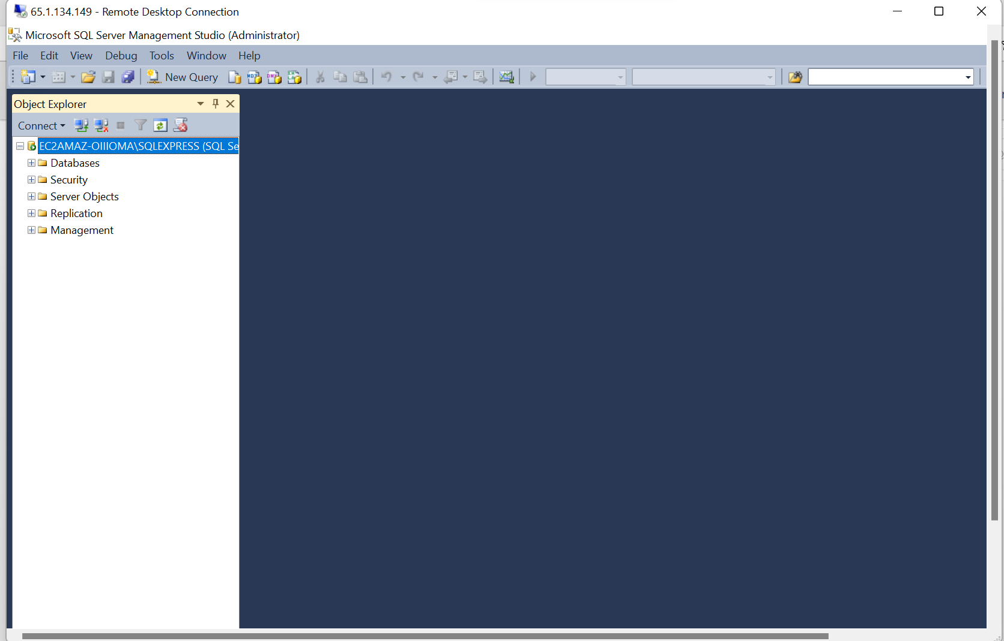

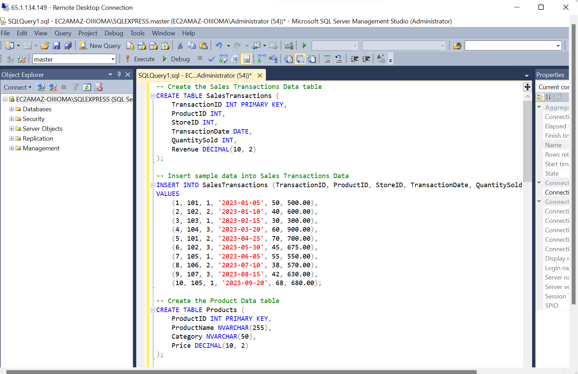

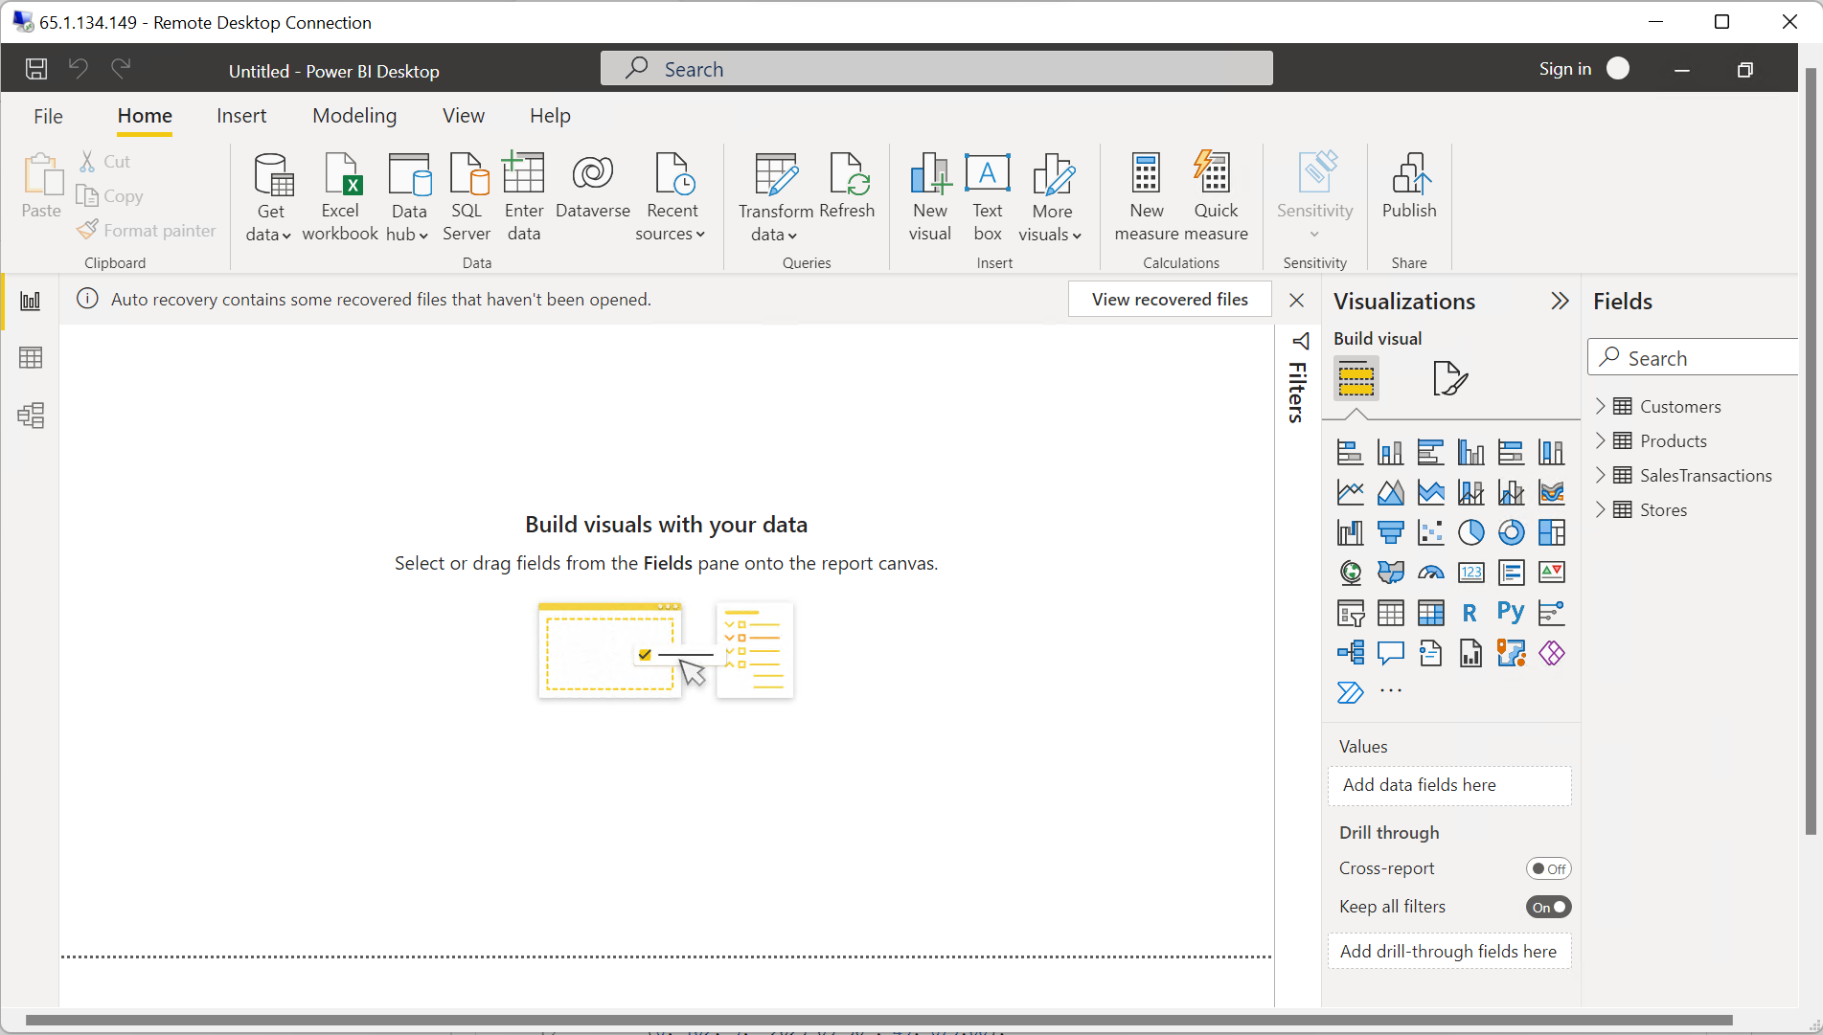

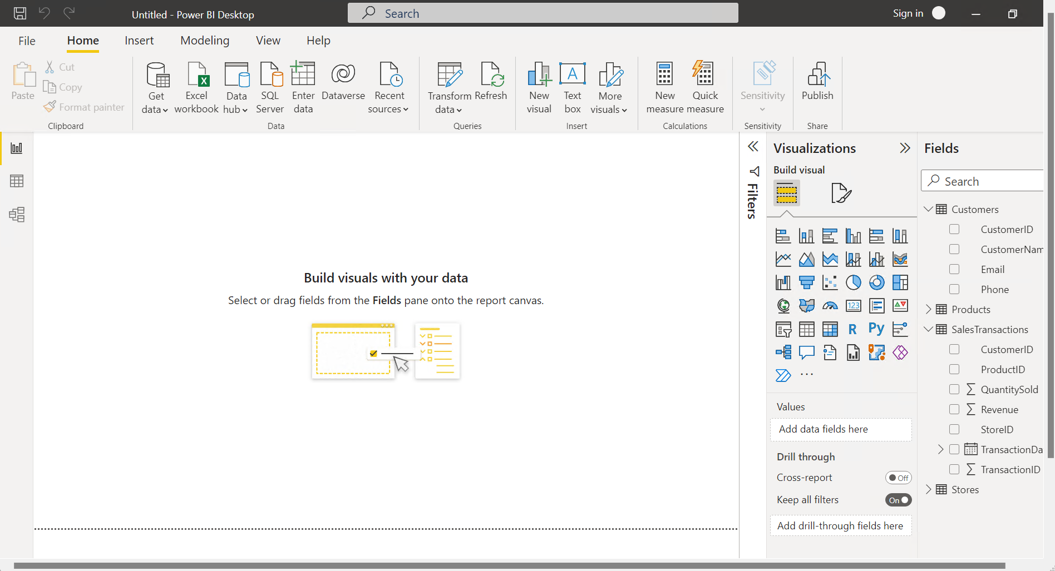

REQUIREMENT 2:

Data Transformation-:

1. Merge Tables

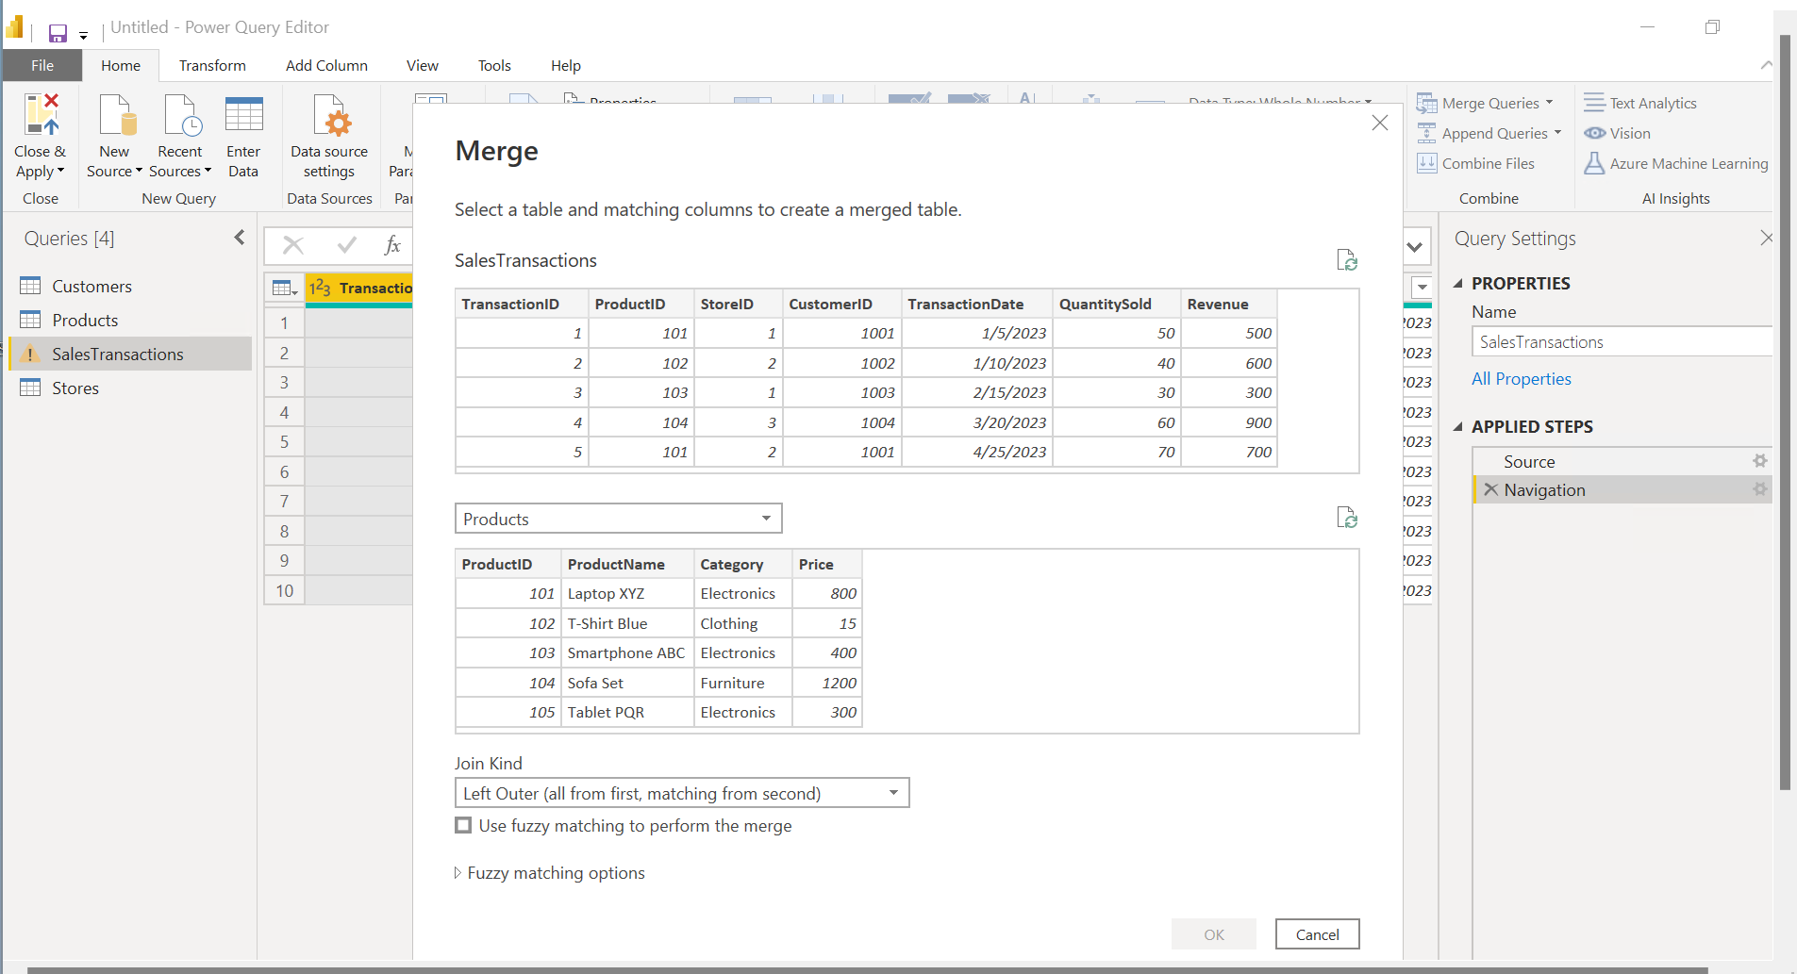

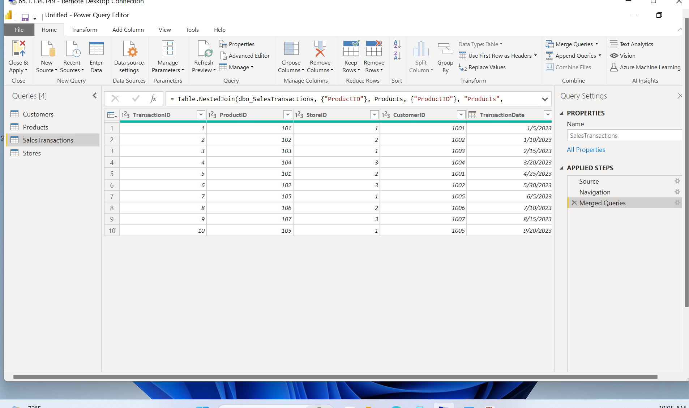

1. Clean data

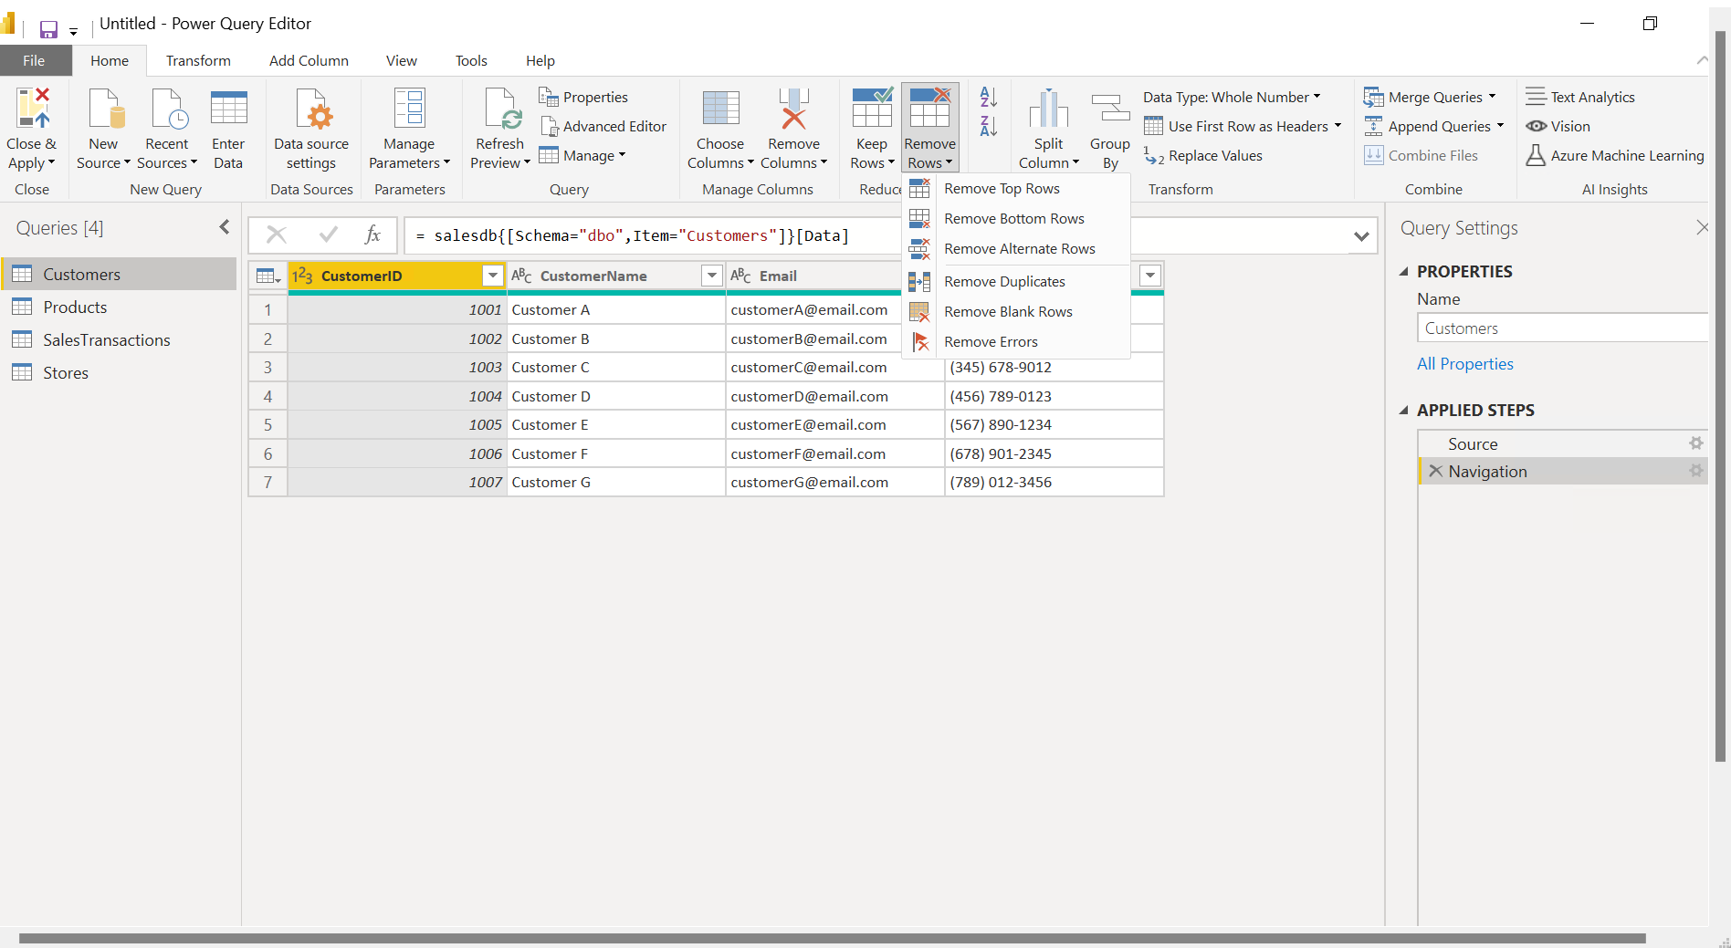

Remove duplicates

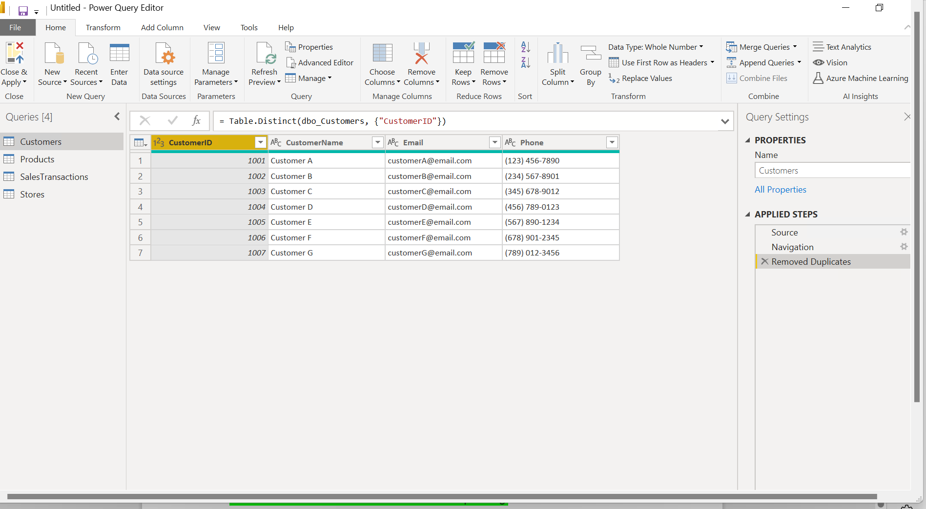

Remove errors

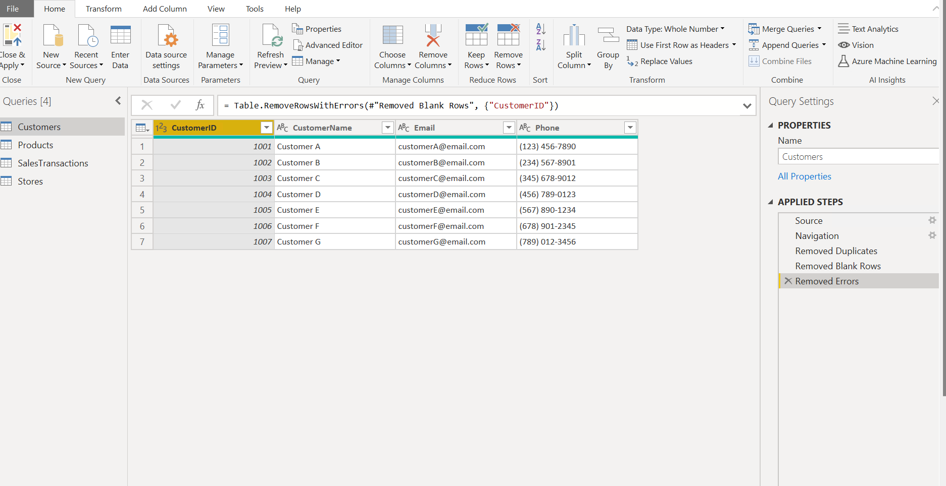

Remove blank rows



1. New calculate measure

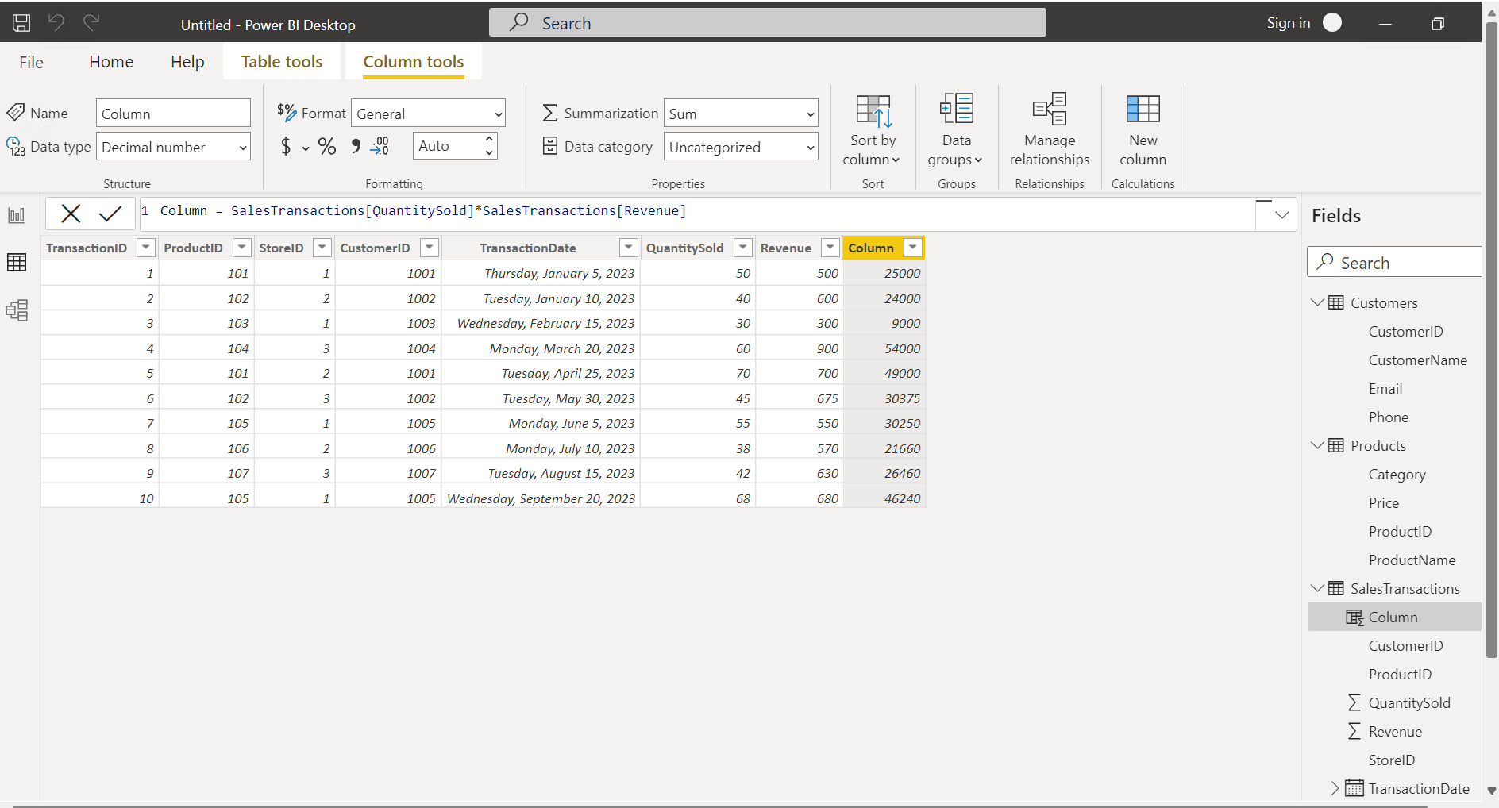

1. Filter data

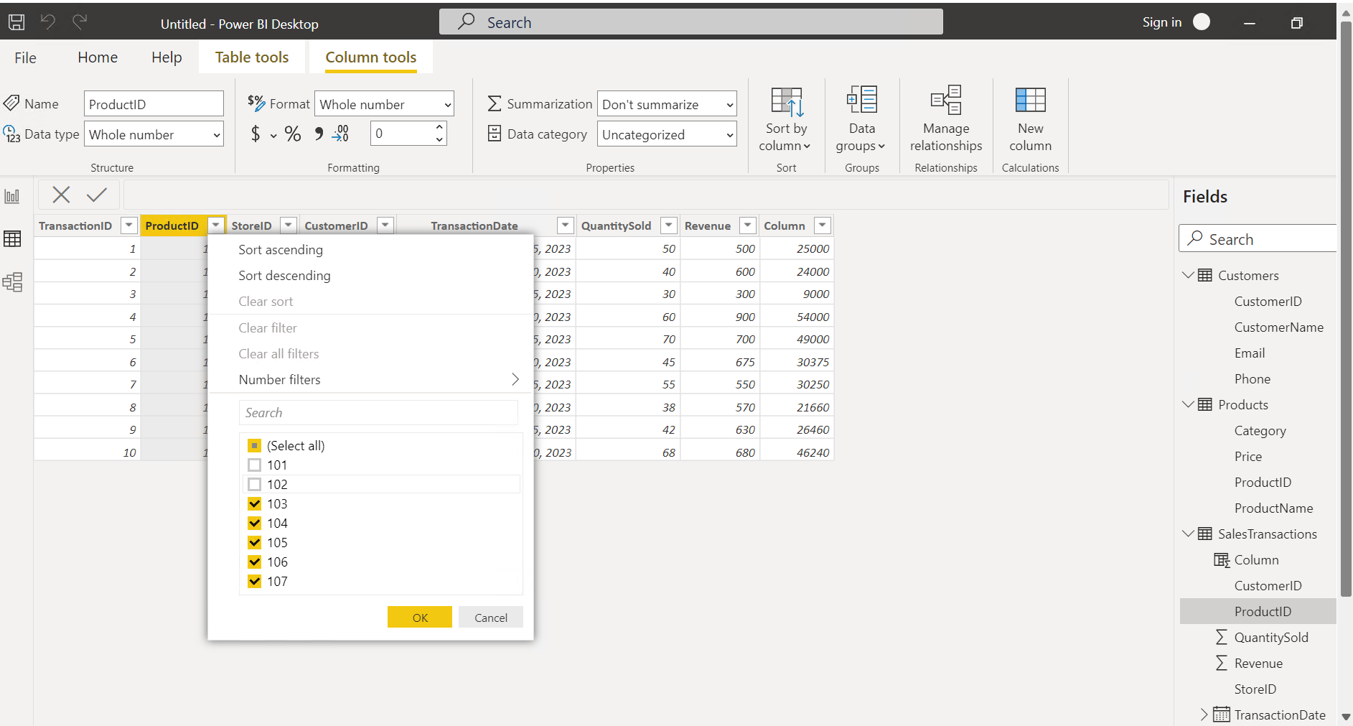

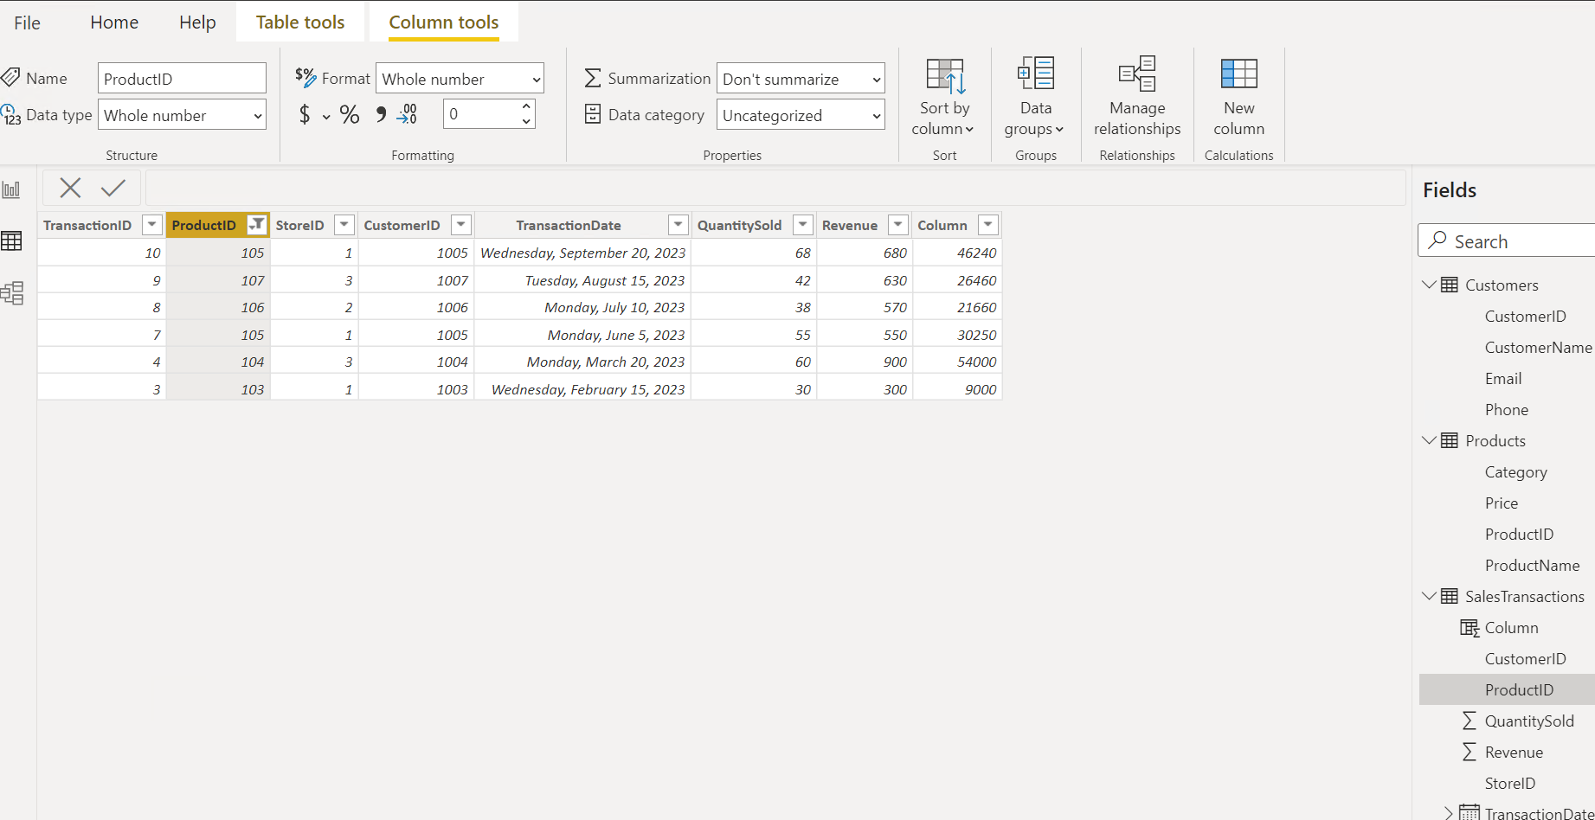

REQUIREMENT 3: Data Modelling

1. Create Relationships

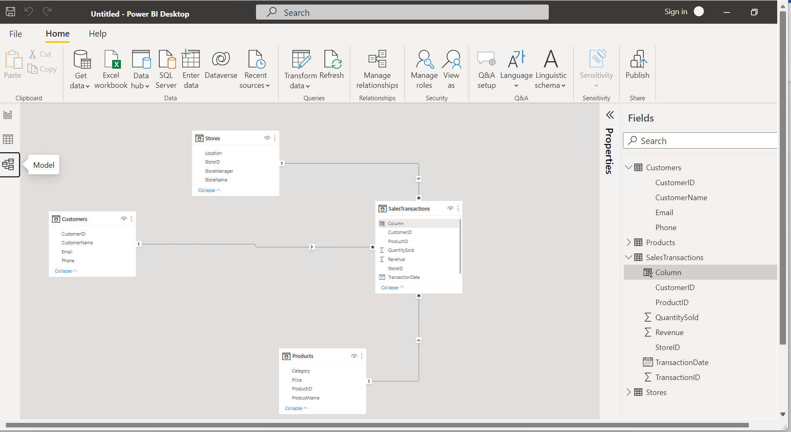

1. Create hierarchy

Creation of hierarchy between category and product name .

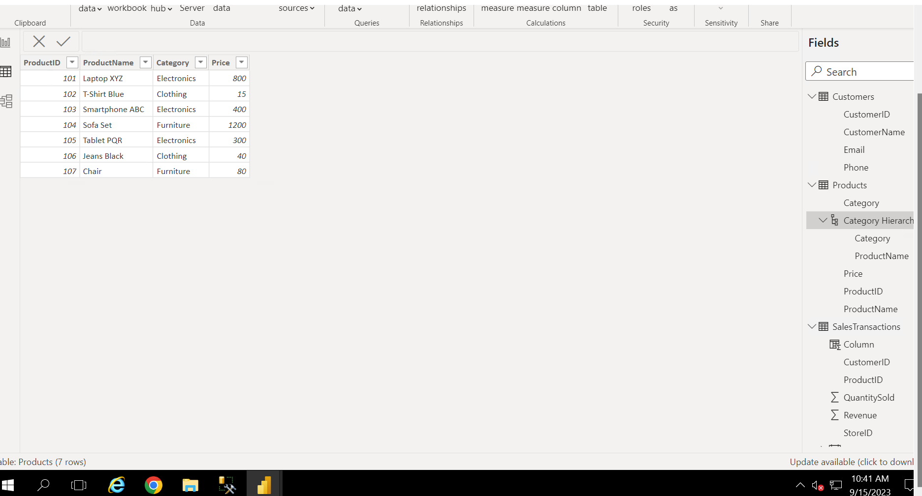

Requirement 4: Business Queries and analysis

1. Who are the top-spending customers based on their total purchase amount?

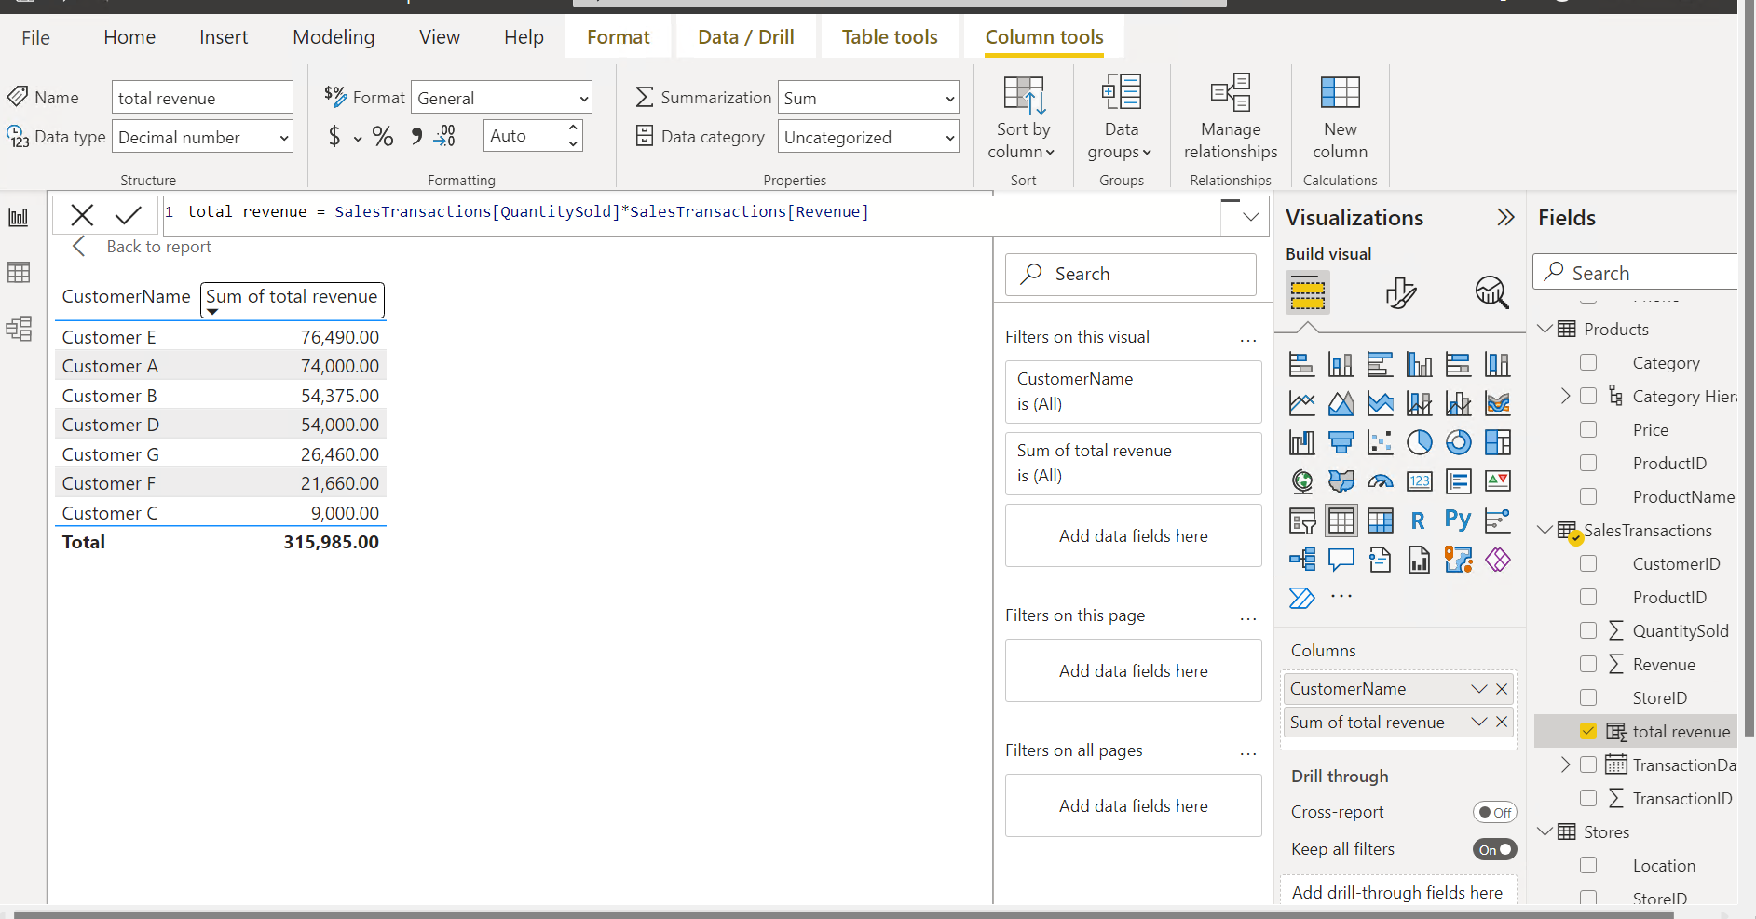

2. How is sales revenue distributed among different store managers?

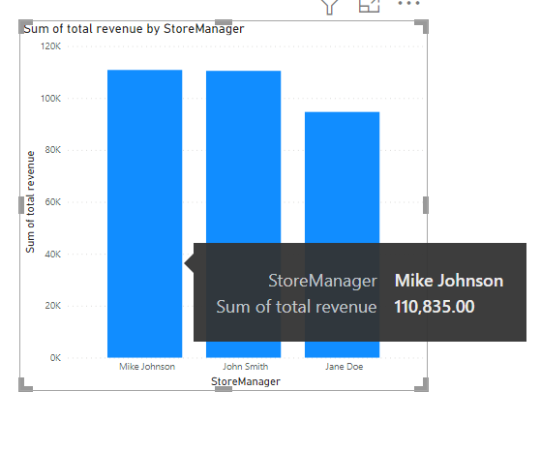

3. What is the average price of products in each category?

. 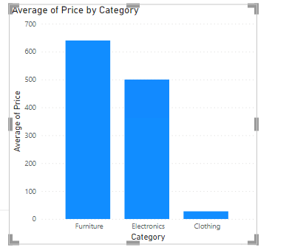

4. Are there specific days of the week when sales are higher?

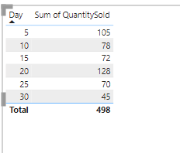

5. How do sales trends vary by product category on a monthly basis?

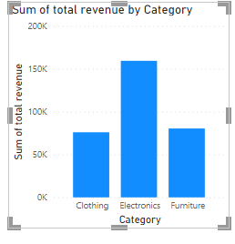

6. What percentage of products account for 80% of total sales revenue?

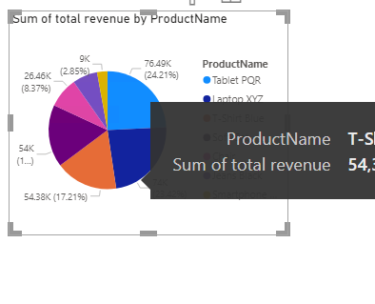

7. Are there any trends in repeat customer purchases?

According to the trend customers buys the same product again.

8. Which product categories perform best at each store loca;on?

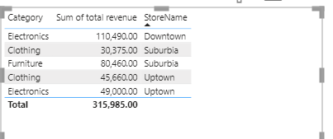

9. Are there any seasonal paSerns or trends in sales for specific products or categories?

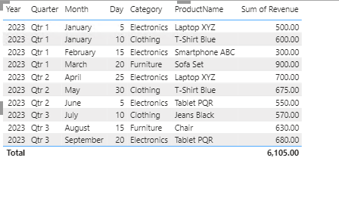

10. Can customers be segmented into high, medium, and low-value segments based on their purchase history?

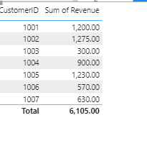

REQUIREMENT 5:

1. The pattern for each product has been published monthwise. Its been observed that customer buys product repeatedly.



1. 

The revenue for each category has been set .

1. 

